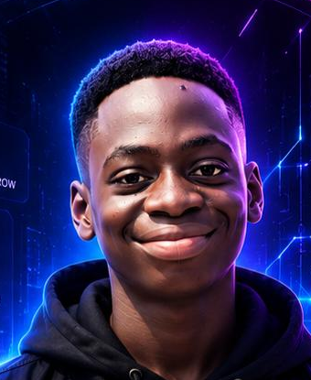 | TOMIWA WOLE OLOWO  Web3 Community Builder & Developer  Nigeria · woleolowotomiwa@gmail.com  X:Web3T_W_O Telegram: Web3T_W_O GitHub: Web3TWO
Professional Summary
Web3 Community Builder and Developer passionate about building online communities, creating engaging digital content, and developing practical web experiences. Experienced in community management, content creation, Web3 projects, and frontend development using HTML, CSS, and JavaScript. I enjoy connecting with people, supporting growing communities, and turning ideas into useful digital experiences.
Work Experience
Ambassador 2026 – Present
Moove.xyz
- Represent and promote Moove within the Web3 community.
- Create educational and engaging content around Moove products and initiatives.
- Participate in community campaigns, ambassador activities, and discussions.
- Help introduce new users to Moove and its ecosystem.
Social Media Manager & Moderator 2026 – Present
dePick Nigeria
- Manage and create social media content for the community.
- Engage with community members and maintain an active online presence.
- Moderate community discussions and help maintain a welcoming environment.
- Support community activities, campaigns, and user engagement.
Core Skills
Community Management |  | Social Media Management |  | Content Creation |  | Content Writing
Web Development |  | HTML / CSS / JavaScript |  | Graphic Design |  | Web3 & Crypto
Community Moderation |  | Discord Server Setup |  | Ambassador Programs |  | User Engagement
Technical Stack
Frontend: HTML, CSS, JavaScript
Community tools: Discord (server setup & moderation), Telegram, X/Twitter
Creative: Graphic design, content writing, educational content
Domain: Web3, crypto communities, ambassador programs
Building. Creating. Impacting.

